# Supplier Cost Refresh Technical Design Options

## Problem

Over the last several months, supplier catalogs have been extracted from the BlueCube production database and imported into the Future ESO Production database. This is done to prepare for a pilot phase and system cutover from BlueCube to ESO. This process established the catalogs with the cost at the time of the extraction from BlueCube, so any cost changes made after the extraction are not reflected in ESO. There is not one specific point in time that can use used to determine what price changes have been missed because incremental new items and new or missed suppliers must be accounted for, however, this can be approximated using the logs of the extraction processed and internal timestamps.

The JDA Catalog import does not support multiple prices for a supplier cost level, so it is also the case that promotions and future price changes have not been imported into ESO correctly.

There is no JDA import for cost change events, however, it is possible to leverage the JDA catalog import to simulate cost change events by importing multiple catalogs for distinct cost changes.

To avoid excessive data entry and errors, a process will be implemented to extract the missing cost changes from BC and import the changes into ESO. This will be one time per supplier as the supplier is needed for stores cutting over to ESO.

## Notes/Assumptions

All options will have data separated by the supplier. This is required for the JDA catalog import and provides advantages in data size and problem determination.

For those suppliers selected to use this process, there should be no manual supplier cost maintenance in ESO Prod.

## Options

Option 1 - Use the modified version of the catalog extract along with additional data made available to BC.

This option would be based on the existing catalog extracted files; however, the extract rule would be changed. The rule would be to extract those supplier items that have cost changes that are not in ESO but still in effect in BlueCube. If there are future cost changes, it will be necessary to provide more than one catalog file for the supplier. The problem with this solution is that the supplier catalogs require supplier item attributes that may have changed within ESO during the processing of cleansing the catalog import data. To get around this problem, the catalog extract files should contain the attributes from the ESO system along with the cost from the BC system. It is likely that the attributes pulled from ESO will not have to be 100% complete. For example, if the barcodes are omitted from the import files, importing the catalog files should not remove the barcodes from ESO. This will need to be validated.

The best way to address this is to make the supplier attributes available to the BC extract, either in the form of a worktable or by linking to BC and ESO DB servers.

Option 1

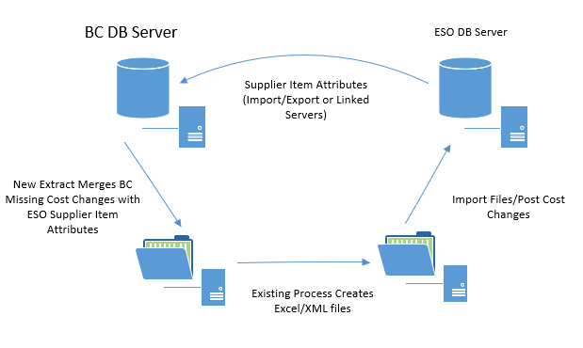

Drawbacks

The drawback to this solution is that both methods of providing the ESO attributes to the BC extract are problematic. For the worktable option, there would be quite of a bit of data that would need to reside on the BC server. For the linked server option, there will be configuration changes needed for the BC and ESO production servers and the performance of the data extract may not be acceptable and it may adversely impact the BC production system.

Advantages

The advantage of this approach is that it reuses a good portion of the existing framework to create spreadsheets and import the data into ESO. The data can be reviewed for accuracy if desired.

Option 2 - Use a cost change extract and custom import into ESO along with the existing catalog extract and import framework.

This option would be based on a custom extract of the missing cost changes from BC and a custom import of the changes into ESO. The result will be a missing supplier item cost worktable in the ESO database. This option will use the same logic to determine what cost changes are missing as Option 1. The second piece of this option will be a modified version of the existing supplier catalog extract that uses the supplier cost change worktable table in lieu of the standard cost change table. It will use the same export data framework only rather than exporting from BC, the export will be from ESO. Like Option 1, it is likely that the attributes pulled from ESO will not have to be 100% complete.

Because the extracted attribute data is from ESO, this option bypasses the need to address the supplier item attribute differences between BC and ESO.

Option 2

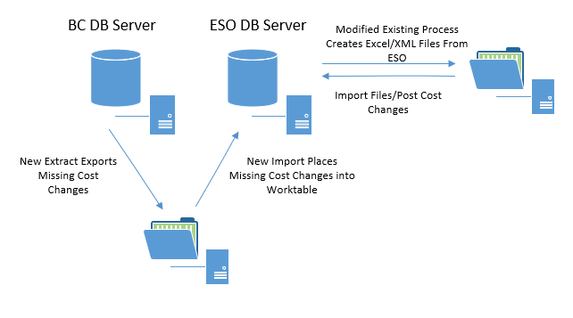

Drawbacks

Custom extraction and import scripts for the missing cost data will need to be created. The data will have to be moved from the BC system to the ESO system.

Advantages

This option is less impactful to the BC production system. No additional data will need to be stored there and no additional server configuration will be required which minimizes the risk to the production environment.

Relative to Option 1, there will be less total data exchanged between the two systems.

This option is architecturally simpler than option 1.

As with Option 1, this approach reuses a good portion of the existing framework to create spreadsheets and import the data into ESO. The data can be reviewed for accuracy if desired.

Option 3 – Custom extract of cost changes and custom import of cost changes event.

This option would be based on a custom extract of cost changes from BC and custom import of cost change events into ESO. It would not utilize any pieces of the existing framework. Missing cost changes would be extracted from BC and imported into ESO. New cost change events will be created in draft status.

Option 3

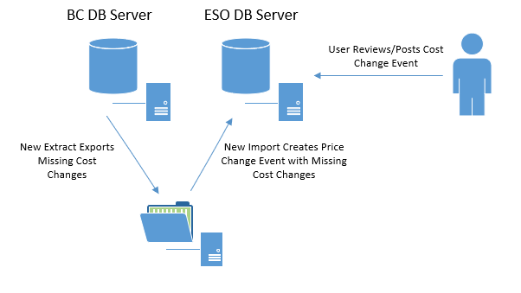

Drawbacks

Imports data directly into JDA tables (Merch Price Change Event and Merch Cost Change).

Advantages

Low overhead and processing time. There is no need to generate spreadsheet files. Allows the user to review cost changes using the existing price change event user interface and provides a clear record of what was imported and changed.